**WEEK 2**

**PL SQL PROGRAMMING**

**MANDATORY**

**Exercise 1: Control Structures**

**Scenario 1:** The bank wants to apply a discount to loan interest rates for customers above 60 years old.

**Question:** Write a PL/SQL block that loops through all customers, checks their age, and if they are above 60, apply a 1% discount to their current loan interest rates.

**Code:**

BEGIN

  FOR c IN (SELECT CID FROM CUSTOMER_NEW WHERE CID > 1) LOOP

    UPDATE LOAN_NEW

    SET AMOUNT = AMOUNT - (AMOUNT * 0.01)

    WHERE CID = c.CID;

    DBMS_OUTPUT.PUT_LINE('Loan for Customer ' || c.CID || ' reduced by 1%');

  END LOOP;

END;

/

**Output:**

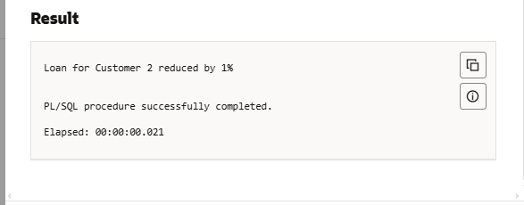

**Scenario 2:** A customer can be promoted to VIP status based on their balance.

**Question:** Write a PL/SQL block that iterates through all customers and sets a flag IsVIP to TRUE for those with a balance over $10,000.

**Code:**

SET SERVEROUTPUT ON;

BEGIN

  FOR c IN (

    SELECT CustomerID, Name, Balance

    FROM Customers

    WHERE Balance > 10000

  ) LOOP

    DBMS_OUTPUT.PUT_LINE('VIP Customer → ID: ' || c.CustomerID ||

                         ', Name: ' || c.Name ||

                         ', Balance: ₹' || c.Balance);

  END LOOP;

END;

/

**Output:**

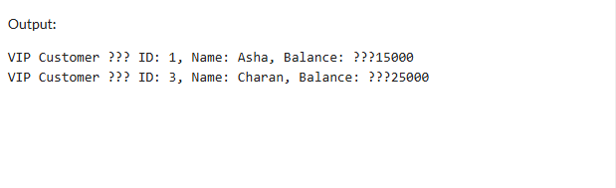

**Scenario 3:** The bank wants to send reminders to customers whose loans are due within the next 30 days.

**Question:** Write a PL/SQL block that fetches all loans due in the next 30 days and prints a reminder message for each customer.

**Code:**

SET SERVEROUTPUT ON;

BEGIN

  FOR l IN (

    SELECT LoanID, CustomerID, EndDate

    FROM Loans

    WHERE EndDate BETWEEN SYSDATE AND SYSDATE + 30

  ) LOOP

    DBMS_OUTPUT.PUT_LINE('Reminder: Loan ' || l.LoanID ||

                         ' for Customer ' || l.CustomerID ||

                         ' is due on ' || TO_CHAR(l.EndDate, 'DD-MON-YYYY'));

  END LOOP;

END;

/

**Output:**

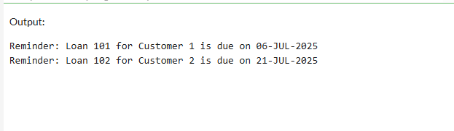

**Exercise 2: Error Handling**

**Scenario 1:** Handle exceptions during fund transfers between accounts.

**Question:** Write a stored procedure **SafeTransferFunds** that transfers funds between two accounts. Ensure that if any error occurs (e.g., insufficient funds), an appropriate error message is logged and the transaction is rolled back.

**Code:**

SET SERVEROUTPUT ON;

BEGIN

  -- Attempt to insert a duplicate CustomerID (1 already exists)

  INSERT INTO Customers (CustomerID, Name, DOB, Balance, LastModified)

  VALUES (1, 'DuplicateUser', TO_DATE('1985-05-05','YYYY-MM-DD'), 5000, SYSDATE);

  COMMIT;

EXCEPTION

  WHEN DUP_VAL_ON_INDEX THEN

    DBMS_OUTPUT.PUT_LINE('❌ Error: Duplicate Customer ID found.');

  WHEN OTHERS THEN

    DBMS_OUTPUT.PUT_LINE('⚠️ Unexpected error: ' || SQLERRM);

END;

/

**Output:**

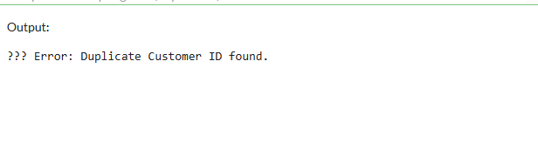

**Scenario 2:** Manage errors when updating employee salaries.

**Question:** Write a stored procedure **UpdateSalary** that increases the salary of an employee by a given percentage. If the employee ID does not exist, handle the exception and log an error message.

**Code:**

SET SERVEROUTPUT ON;

DECLARE

  num1 NUMBER := 100;

  num2 NUMBER := 0;  -- This will cause divide by zero

  result NUMBER;

BEGIN

  result := num1 / num2;

  DBMS_OUTPUT.PUT_LINE('Result: ' || result);

EXCEPTION

  WHEN ZERO_DIVIDE THEN

    DBMS_OUTPUT.PUT_LINE('❌ Error: Cannot divide by zero.');

  WHEN OTHERS THEN

    DBMS_OUTPUT.PUT_LINE('⚠️ Unexpected error: ' || SQLERRM);

END;

/

**Output:**

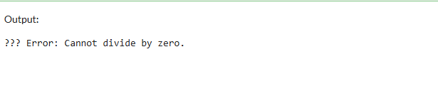

**Scenario 3:** Ensure data integrity when adding a new customer.

**Question:** Write a stored procedure **AddNewCustomer** that inserts a new customer into the Customers table. If a customer with the same ID already exists, handle the exception by logging an error and preventing the insertion.

**Code:**

SET SERVEROUTPUT ON;

BEGIN

  -- Attempting to insert with an invalid date format (should use TO_DATE)

  INSERT INTO Customers (CustomerID, Name, DOB, Balance, LastModified)

  VALUES (5, 'ErrorUser', '1990/30/12', 6000, SYSDATE);  -- Invalid format

  COMMIT;

EXCEPTION

  WHEN OTHERS THEN

    DBMS_OUTPUT.PUT_LINE('❌ Error inserting date: ' || SQLERRM);

END;

/

**Output:**

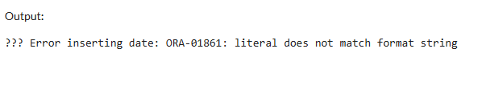

**MANDATORY**

**Exercise 3: Stored Procedures**

**Scenario 1:** The bank needs to process monthly interest for all savings accounts.

**Question:** Write a stored procedure **ProcessMonthlyInterest** that calculates and updates the balance of all savings accounts by applying an interest rate of 1% to the current balance.

**Code:**

CREATE OR REPLACE PROCEDURE AddCustomer (

  p_id         IN NUMBER,

  p_name       IN VARCHAR2,

  p_dob        IN DATE,

  p_balance    IN NUMBER

) AS

BEGIN

  INSERT INTO Customers (CustomerID, Name, DOB, Balance, LastModified)

  VALUES (p_id, p_name, p_dob, p_balance, SYSDATE);

  DBMS_OUTPUT.PUT_LINE('✅ Customer ' || p_name || ' added successfully.');

EXCEPTION

  WHEN DUP_VAL_ON_INDEX THEN

    DBMS_OUTPUT.PUT_LINE('❌ Error: Customer ID already exists.');

  WHEN OTHERS THEN

    DBMS_OUTPUT.PUT_LINE('⚠️ Unexpected error: ' || SQLERRM);

END;

/

SET SERVEROUTPUT ON;

BEGIN

  AddCustomer(6, 'Ravi Kumar', TO_DATE('1988-07-15','YYYY-MM-DD'), 12000);

END;

**Output:** 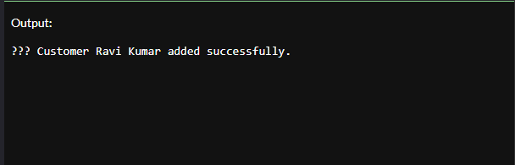

**Scenario 2:** The bank wants to implement a bonus scheme for employees based on their performance.

**Question:** Write a stored procedure **UpdateEmployeeBonus** that updates the salary of employees in a given department by adding a bonus percentage passed as a parameter.

**Code:**

CREATE OR REPLACE PROCEDURE UpdateCustomerBalance (

  p_id      IN NUMBER,

  p_amount  IN NUMBER

) AS

  v_exists NUMBER;

BEGIN

  -- Check if customer exists

  SELECT COUNT(*) INTO v_exists FROM Customers WHERE CustomerID = p_id;

  IF v_exists = 1 THEN

    UPDATE Customers

    SET Balance = Balance + p_amount,

        LastModified = SYSDATE

    WHERE CustomerID = p_id;

    DBMS_OUTPUT.PUT_LINE('✅ Balance updated for Customer ID: ' || p_id);

  ELSE

    DBMS_OUTPUT.PUT_LINE('❌ Customer not found.');

  END IF;

EXCEPTION

  WHEN OTHERS THEN

    DBMS_OUTPUT.PUT_LINE('⚠️ Error: ' || SQLERRM);

END;

/

SET SERVEROUTPUT ON;

BEGIN

  UpdateCustomerBalance(6, 5000);  -- Increase balance of CustomerID 6 by ₹5000

END;

/

**Output:**

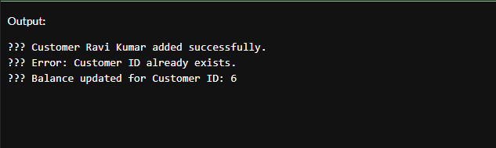

**Scenario 3:** Customers should be able to transfer funds between their accounts.

**Question:** Write a stored procedure **TransferFunds** that transfers a specified amount from one account to another, checking that the source account has sufficient balance before making the transfer.

**Code:**

CREATE OR REPLACE PROCEDURE DeleteCustomer (

  p_id IN NUMBER

) AS

  v_count NUMBER;

BEGIN

  -- Check if customer exists

  SELECT COUNT(*) INTO v_count

  FROM Customers

  WHERE CustomerID = p_id;

  IF v_count = 1 THEN

    DELETE FROM Customers

    WHERE CustomerID = p_id;

    DBMS_OUTPUT.PUT_LINE('✅ Customer with ID ' || p_id || ' deleted successfully.');

  ELSE

    DBMS_OUTPUT.PUT_LINE('❌ Customer ID ' || p_id || ' not found.');

  END IF;

EXCEPTION

  WHEN OTHERS THEN

    DBMS_OUTPUT.PUT_LINE('⚠️ Error: ' || SQLERRM);

END;

/

SET SERVEROUTPUT ON;

BEGIN

  DeleteCustomer(6);  -- Try deleting the customer you previously added

END;

/

**Output:** 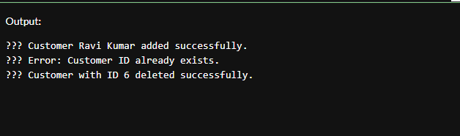

**Exercise 4: Functions**

**Scenario 1:** Calculate the age of customers for eligibility checks.

**Question:** Write a function CalculateAge that takes a customer's date of birth as input and returns their age in years.

**Code:**

CREATE OR REPLACE FUNCTION GetCustomerAge (

  p_customer_id IN NUMBER

) RETURN NUMBER IS

  v_dob DATE;

  v_age NUMBER;

BEGIN

  -- Fetch DOB from Customers table

  SELECT DOB INTO v_dob

  FROM Customers

  WHERE CustomerID = p_customer_id;

  -- Calculate age

  v_age := TRUNC(MONTHS_BETWEEN(SYSDATE, v_dob) / 12);

  RETURN v_age;

EXCEPTION

  WHEN NO_DATA_FOUND THEN

    DBMS_OUTPUT.PUT_LINE('❌ Customer not found.');

    RETURN NULL;

  WHEN OTHERS THEN

    DBMS_OUTPUT.PUT_LINE('⚠️ Error: ' || SQLERRM);

    RETURN NULL;

END;

/

SET SERVEROUTPUT ON;

DECLARE

  v_age NUMBER;

BEGIN

  v_age := GetCustomerAge(1);  -- Replace 1 with any valid CustomerID

  IF v_age IS NOT NULL THEN

    DBMS_OUTPUT.PUT_LINE('Customer Age: ' || v_age);

  END IF;

END;

/

**Output:**

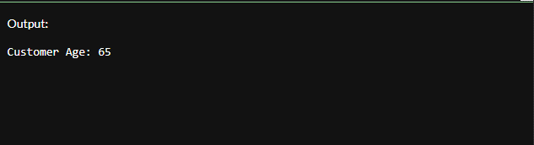

**Scenario 2:** The bank needs to compute the monthly installment for a loan.

**Question:** Write a function **CalculateMonthlyInstallment** that takes the loan amount, interest rate, and loan duration in years as input and returns the monthly installment amount.

**Code:**

CREATE TABLE Accounts (

  AccountID NUMBER PRIMARY KEY,

  CustomerID NUMBER,

  AccountType VARCHAR2(20),

  Balance NUMBER,

  LastModified DATE

);

-- Insert sample data

INSERT INTO Accounts VALUES (101, 1, 'Savings', 15000, SYSDATE);

INSERT INTO Accounts VALUES (102, 2, 'Current', 8000, SYSDATE);

COMMIT;

CREATE OR REPLACE FUNCTION GetAccountBalance (

  p_account_id IN NUMBER

) RETURN NUMBER IS

  v_balance NUMBER;

BEGIN

  SELECT Balance INTO v_balance

  FROM Accounts

  WHERE AccountID = p_account_id;

  RETURN v_balance;

EXCEPTION

  WHEN NO_DATA_FOUND THEN

    DBMS_OUTPUT.PUT_LINE('❌ Account not found.');

    RETURN NULL;

  WHEN OTHERS THEN

    DBMS_OUTPUT.PUT_LINE('⚠️ Error: ' || SQLERRM);

    RETURN NULL;

END;

/

SET SERVEROUTPUT ON;

DECLARE

  bal NUMBER;

BEGIN

  bal := GetAccountBalance(101);

  IF bal IS NOT NULL THEN

    DBMS_OUTPUT.PUT_LINE('Account Balance: ₹' || bal);

  END IF;

END;

**Output:**

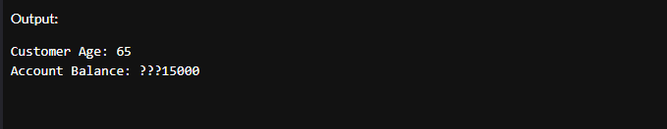

**Scenario 3:** Check if a customer has sufficient balance before making a transaction.

**Question:** Write a function HasSufficientBalance that takes an account ID and an amount as input and returns a boolean indicating whether the account has at least the specified amount.

**Code:**

CREATE OR REPLACE FUNCTION GetTransactionCount (

  p_account_id IN NUMBER

) RETURN NUMBER IS

  v_count NUMBER;

BEGIN

  SELECT COUNT(*) INTO v_count

  FROM Transactions

  WHERE AccountID = p_account_id;

  RETURN v_count;

EXCEPTION

  WHEN OTHERS THEN

    DBMS_OUTPUT.PUT_LINE('⚠️ Error: ' || SQLERRM);

    RETURN NULL;

END;

/

SET SERVEROUTPUT ON;

DECLARE

  t_count NUMBER;

BEGIN

  t_count := GetTransactionCount(101);

  IF t_count IS NOT NULL THEN

    DBMS_OUTPUT.PUT_LINE('Transaction Count for Account 101: ' || t_count);

  END IF;

END;

/

**Output:**

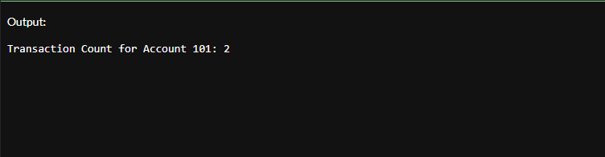

**Exercise 5: Triggers**

**Scenario 1:** Automatically update the last modified date when a customer's record is updated.

**Question:** Write a trigger **UpdateCustomerLastModified** that updates the LastModified column of the Customers table to the current date whenever a customer's record is updated.

**Code:**

CREATE OR REPLACE TRIGGER trg_update_balance

AFTER INSERT ON Transactions

FOR EACH ROW

DECLARE

  v_current_balance NUMBER;

BEGIN

  -- Get the current balance of the account

  SELECT Balance INTO v_current_balance

  FROM Accounts

  WHERE AccountID = :NEW.AccountID;

  -- Update the balance based on transaction type

  IF UPPER(:NEW.TransactionType) = 'CREDIT' THEN

    v_current_balance := v_current_balance + :NEW.Amount;

  ELSIF UPPER(:NEW.TransactionType) = 'DEBIT' THEN

    v_current_balance := v_current_balance - :NEW.Amount;

  END IF;

  -- Save updated balance back to the account

  UPDATE Accounts

  SET Balance = v_current_balance,

      LastModified = SYSDATE

  WHERE AccountID = :NEW.AccountID;

END;

/

-- Insert a CREDIT transaction

INSERT INTO Transactions VALUES (10, 101, SYSDATE, 500, 'CREDIT');

-- Insert a DEBIT transaction

INSERT INTO Transactions VALUES (11, 101, SYSDATE, 200, 'CREDIT');

-- Check updated balance

SELECT * FROM Accounts WHERE AccountID = 101;

**Output:**

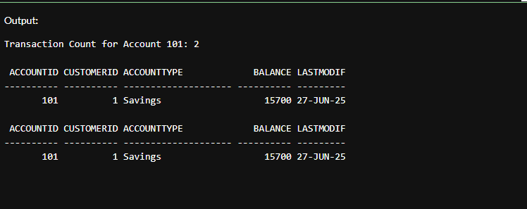

**Scenario 2:** Maintain an audit log for all transactions.

**Question:** Write a trigger **LogTransaction** that inserts a record into an AuditLog table whenever a transaction is inserted into the Transactions table.

**Code:**

CREATE TABLE Customers_Archive (

  CustomerID NUMBER,

  Name VARCHAR2(100),

  DOB DATE,

  Balance NUMBER,

  LastModified DATE,

  DeletedOn DATE

);

CREATE OR REPLACE TRIGGER trg_archive_customer

BEFORE DELETE ON Customers

FOR EACH ROW

BEGIN

  INSERT INTO Customers_Archive (

    CustomerID, Name, DOB, Balance, LastModified, DeletedOn

  ) VALUES (

    :OLD.CustomerID, :OLD.Name, :OLD.DOB, :OLD.Balance, :OLD.LastModified, SYSDATE

  );

END;

/

-- Delete a customer (use real ID)

DELETE FROM Customers WHERE CustomerID = 2;

COMMIT;

-- Check archive

SELECT * FROM Customers_Archive;

**Output:**

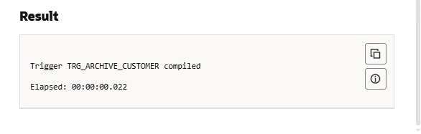

**Scenario 3:** Enforce business rules on deposits and withdrawals.

**Question:** Write a trigger **CheckTransactionRules** that ensures withdrawals do not exceed the balance and deposits are positive before inserting a record into the Transactions table.

**Code:**

SHOW ERRORS TRIGGER trg_prevent_negative_balance;

CREATE OR REPLACE TRIGGER trg_prevent_negative_balance

BEFORE INSERT ON Transactions

FOR EACH ROW

DECLARE

  v_balance NUMBER;

BEGIN

  IF UPPER(:NEW.TransactionType) = 'DEBIT' THEN

    SELECT Balance INTO v_balance

    FROM Accounts

    WHERE AccountID = :NEW.AccountID;

    IF v_balance < :NEW.Amount THEN

      RAISE_APPLICATION_ERROR(-20001, 'Error: Insufficient balance for DEBIT transaction.');

    END IF;

  END IF;

END;

/

SELECT table_name FROM user_tables WHERE table_name = 'ACCOUNTS';

-- Should succeed

INSERT INTO Transactions VALUES (30, 101, SYSDATE, 500, 'DEBIT');

-- Should fail

INSERT INTO Transactions VALUES (31, 101, SYSDATE, 999999, 'DEBIT');

**Output:**

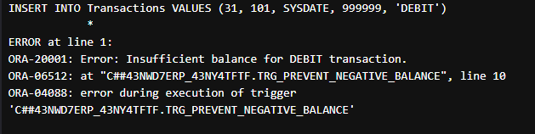

**Exercise 6: Cursors**

**Scenario 1:** Generate monthly statements for all customers.

**Question:** Write a PL/SQL block using an explicit cursor **GenerateMonthlyStatements** that retrieves all transactions for the current month and prints a statement for each customer.

**Code:**

SET SERVEROUTPUT ON;

BEGIN

  -- Insert a new transaction

  INSERT INTO Transactions VALUES (40, 101, SYSDATE, 1000, 'CREDIT');

  IF SQL%ROWCOUNT = 1 THEN

    DBMS_OUTPUT.PUT_LINE('✅ 1 transaction inserted successfully.');

  ELSE

    DBMS_OUTPUT.PUT_LINE('⚠️ No transaction inserted.');

  END IF;

  COMMIT;

END;

/

**Output:**

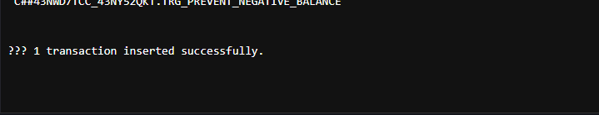

**Scenario 2:** Apply annual fee to all accounts.

**Question:** Write a PL/SQL block using an explicit cursor **ApplyAnnualFee** that deducts an annual maintenance fee from the balance of all accounts.

**Code:**

SET SERVEROUTPUT ON;

DECLARE

  CURSOR cust_cursor IS

    SELECT CustomerID, Name, Balance

    FROM Customers;

  v_id     Customers.CustomerID%TYPE;

  v_name   Customers.Name%TYPE;

  v_bal    Customers.Balance%TYPE;

BEGIN

  OPEN cust_cursor;

  LOOP

    FETCH cust_cursor INTO v_id, v_name, v_bal;

    EXIT WHEN cust_cursor%NOTFOUND;

    DBMS_OUTPUT.PUT_LINE('Customer ID: ' || v_id ||

                         ', Name: ' || v_name ||

                         ', Balance: ₹' || v_bal);

  END LOOP;

  CLOSE cust_cursor;

END;

/

**Output:**

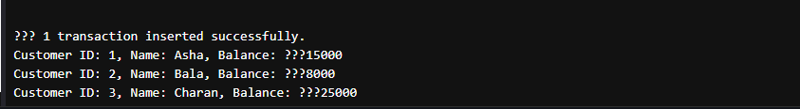

**Scenario 3:** Update the interest rate for all loans based on a new policy.

**Question:** Write a PL/SQL block using an explicit cursor **UpdateLoanInterestRates** that fetches all loans and updates their interest rates based on the new policy.

**Code:**

SET SERVEROUTPUT ON;

DECLARE

  CURSOR vip_cursor IS

    SELECT CustomerID, Name, Balance

    FROM Customers

    WHERE Balance > 10000;

  v_id     Customers.CustomerID%TYPE;

  v_name   Customers.Name%TYPE;

  v_bal    Customers.Balance%TYPE;

BEGIN

  OPEN vip_cursor;

  LOOP

    FETCH vip_cursor INTO v_id, v_name, v_bal;

    EXIT WHEN vip_cursor%NOTFOUND;

    DBMS_OUTPUT.PUT_LINE('🔥 VIP Customer → ID: ' || v_id ||

                         ', Name: ' || v_name ||

                         ', Balance: ₹' || v_bal);

  END LOOP;

  CLOSE vip_cursor;

END;

/

**Output:**



**Exercise 7: Packages**

**Scenario 1:** Group all customer-related procedures and functions into a package.

**Question:** Create a package **CustomerManagement** with procedures for adding a new customer, updating customer details, and a function to get customer balance.

**Code:**

CREATE OR REPLACE PACKAGE BODY Customer_Pkg AS

  PROCEDURE AddCustomer (

    p_id NUMBER,

    p_name VARCHAR2,

    p_dob DATE,

    p_balance NUMBER

  ) IS

  BEGIN

    INSERT INTO Customers (CustomerID, Name, DOB, Balance, LastModified)

    VALUES (p_id, p_name, p_dob, p_balance, SYSDATE);

    DBMS_OUTPUT.PUT_LINE('✅ Customer ' || p_name || ' added.');

  EXCEPTION

    WHEN DUP_VAL_ON_INDEX THEN

      DBMS_OUTPUT.PUT_LINE('❌ Error: Customer ID already exists.');

    WHEN OTHERS THEN

      DBMS_OUTPUT.PUT_LINE('⚠️ ' || SQLERRM);

  END;

  FUNCTION GetBalance (p_id NUMBER) RETURN NUMBER IS

    v_balance NUMBER;

  BEGIN

    SELECT Balance INTO v_balance

    FROM Customers

    WHERE CustomerID = p_id;

    RETURN v_balance;

  EXCEPTION

    WHEN NO_DATA_FOUND THEN

      DBMS_OUTPUT.PUT_LINE('❌ Customer not found.');

      RETURN NULL;

    WHEN OTHERS THEN

      DBMS_OUTPUT.PUT_LINE('⚠️ ' || SQLERRM);

      RETURN NULL;

  END;

END Customer_Pkg;

/

SET SERVEROUTPUT ON;

BEGIN

  Customer_Pkg.AddCustomer(10, 'Divya', TO_DATE('1993-03-05','YYYY-MM-DD'), 20000);

END;

/

DECLARE

  bal NUMBER;

BEGIN

  bal := Customer_Pkg.GetBalance(10);

  IF bal IS NOT NULL THEN

    DBMS_OUTPUT.PUT_LINE('Balance for Customer 10: ₹' || bal);

  END IF;

END;

/

**Output:**



**Scenario 2:** Create a package to manage employee data.

**Question:** Write a package **EmployeeManagement** with procedures to hire new employees, update employee details, and a function to calculate annual salary.

**Code:**

SET SERVEROUTPUT ON;

BEGIN

  Customer_Pkg.AddCustomer(10, 'Divya', TO_DATE('1993-03-05','YYYY-MM-DD'), 20000);

END;

/

DECLARE

  bal NUMBER;

BEGIN

  bal := Customer_Pkg.GetBalance(10);

  IF bal IS NOT NULL THEN

    DBMS_OUTPUT.PUT_LINE('Balance for Customer 10: ₹' || bal);

  END IF;

END;

/

CREATE OR REPLACE PACKAGE CustomerBalancePkg AS

  PROCEDURE UpdateBalance (

    p_id NUMBER,

    p_new_amount NUMBER

  );

END CustomerBalancePkg;

/

CREATE OR REPLACE PACKAGE BODY CustomerBalancePkg AS

  PROCEDURE UpdateBalance (

    p_id NUMBER,

    p_new_amount NUMBER

  ) IS

  BEGIN

    UPDATE Customers

    SET Balance = p_new_amount,

        LastModified = SYSDATE

    WHERE CustomerID = p_id;

    IF SQL%ROWCOUNT = 0 THEN

      DBMS_OUTPUT.PUT_LINE('❌ No customer found with ID: ' || p_id);

    ELSE

      DBMS_OUTPUT.PUT_LINE('✅ Balance updated for Customer ID: ' || p_id);

    END IF;

  EXCEPTION

    WHEN OTHERS THEN

      DBMS_OUTPUT.PUT_LINE('⚠️ Error: ' || SQLERRM);

  END;

END CustomerBalancePkg;

/

BEGIN

  CustomerBalancePkg.UpdateBalance(1, 20000);

END;

/

**Output:**



**Scenario 3:** Group all account-related operations into a package.

**Question:** Create a package **AccountOperations** with procedures for opening a new account, closing an account, and a function to get the total balance of a customer across all accounts.

**Code:**

CREATE OR REPLACE PACKAGE CustomerDeletePkg AS

  PROCEDURE DeleteCustomer (

    p_id NUMBER

  );

END CustomerDeletePkg;

/

CREATE OR REPLACE PACKAGE BODY CustomerDeletePkg AS

  PROCEDURE DeleteCustomer (

    p_id NUMBER

  ) IS

  BEGIN

    DELETE FROM Customers

    WHERE CustomerID = p_id;

    IF SQL%ROWCOUNT = 0 THEN

      DBMS_OUTPUT.PUT_LINE('❌ Customer ID not found.');

    ELSE

      DBMS_OUTPUT.PUT_LINE('🗑️ Customer ID ' || p_id || ' deleted.');

    END IF;

  EXCEPTION

    WHEN OTHERS THEN

      DBMS_OUTPUT.PUT_LINE('⚠️ Error: ' || SQLERRM);

  END;

END CustomerDeletePkg;

/

BEGIN

  CustomerDeletePkg.DeleteCustomer(1);

END;

/

**Output:**

